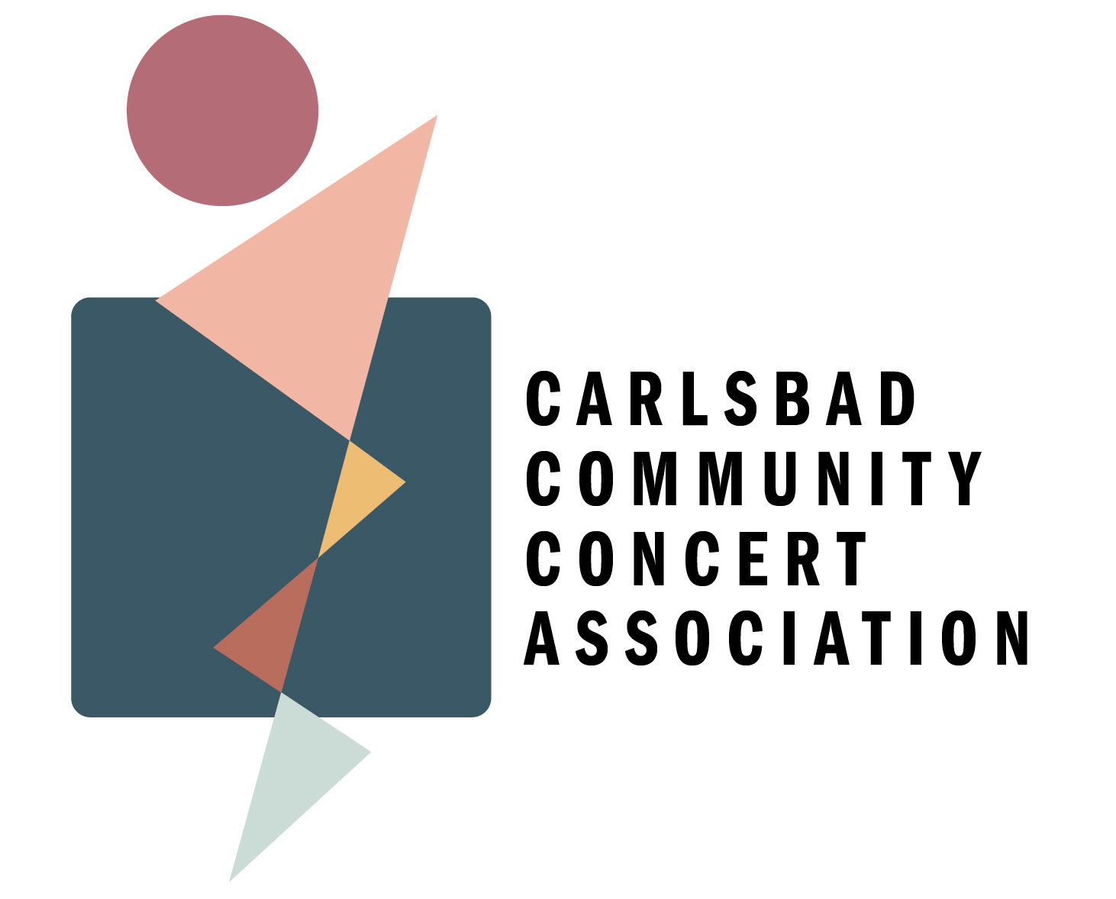

Request for Support of the Performing Arts:

Carlsbad Community Concert Association - CCCA

**2024 Concert Season**

The CCCA has brought musical performance to Carlsbad for over 80 years. Our mission is to enrich the quality of life in the Cavern City through world-class performances of many genres- from classical and jazz, to folk and fusion.

Individual Membership to the 2024 season will support some of our endeavors, but not all. We invite you to support the CCCA as we broaden access to Arts and Culture in Carlsbad.

Invitation to participate as a **Major Donor -** **$10,000**

* All employees receive season Membership for two adults; all additional guests enter at half price;
* Children under 18 enter free of charge;
* We reserve for Major Donors a dedicated seat on the CCCA Advisory Board to help drive community enrichment in the performing arts;
* Acknowledgement of sponsorship on all advertising and at events.

Invitation to participate as a **Sponsor -** **$5,000**

* 50 season Memberships for two adults; all additional guests enter at half price;
* Children under 18 enter free of charge;
* We reserve for Sponsors a dedicated seat on the CCCA Advisory Board to help drive community enrichment in the performing arts;
* Acknowledgement of sponsorship on all advertising and at events.

Invitation to participate as a **Patron -** **$1,000**

* Season Membership for two adults; all additional guests enter at half price;
* Children under 18 enter free of charge;
* Acknowledgement of sponsorship on event programs.

The CCCA is committed to offering:

* Multiculturally diverse performing artists to embrace the whole of Carlsbad’s community;
* Strong educational enrichment opportunities with workshops and outreach to local schools and children’s groups;
* Four (4) concerts throughout the calendar year.

***Alternatively***

Invitation to be **Title Sponsor** of one concert exclusively.

*About the Carlsbad Community Concert Association*

Officially founded in 1943, the CCCA has enriched the Carlsbad community by bringing performing artists to the Cavern City for over 80 years. Through the patronage of member families and corporate sponsorships, the CCCA offers an annual concert series with a varied repertoire of classical, jazz, contemporary and R&B offerings as well as dance, folk and world music.

Our 2024 season will include multicultural music and dance, with some classical standards featuring the Concert Association’s much beloved Steinway Concert Piano.

Carlsbad is a city focusing on STEM enrichment. The Carlsbad Community Concert Association invites you to broaden our horizons. With a STEM approach, we can include the ARTs among science, technology, engineering, and math for a more inclusive, more broadly strengthened community.

Please join us in creating a community where the Arts thrive, and there’s always something enriching on the calendar.

Stephanie Ybaben

Carlsbad Community Concerts- CCCA

PO Box 1712

Carlsbad, NM 88221

[carlsbadcommunityconcert@gmail.com](mailto:carlsbadcommunityconcert@gmail.com)

575.499.9032